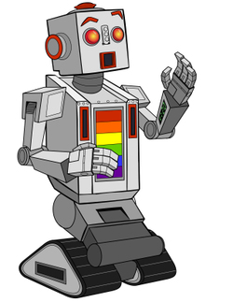
Application of Trigonometry

Forward Kinematics
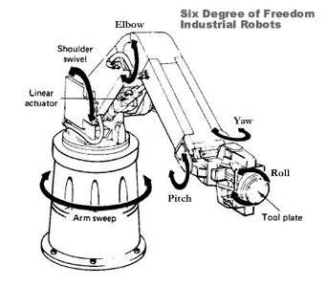
What goes through your mind when you reach out to pick up your toothbrush in the morning? Probably not a lot that early in the day. But if you stop and think about it there are a whole series of calculations that need to be made to get your shoulder, elbow and wrist at the right angles to put your hand where it needs to be. Fortunately you have the most powerful learning engine in existence doing all this in the background so you never even realise it happens. But what about a robotic arm? Each of the angles of each joint need to be calculated to get the arm into the correct position. A robotic arm’s manoeuvrability is defined by its degrees of freedom. The robotic arm in the diagram left has six degrees of freedom, meaning it can rotate six different elements to get into a desired position.
The mathematics of determining where the end effector of a robotic arm will be based on the angles of its joints is called forward kinematics. Open up the file Robot Arm Simulator Student.xls. Enter values of 45° for Angle 1 – 3 and note the position of the end effector. Spend some time experimenting with different angles (positive and negative up to 360) and lengths. Ignore X, Y and φ_{h} for now. Consider the robot arm position shown below. The angles are marked on the diagram.
- Produce this same end position in your simulator file.
Note: You’ll need different angles to those shown in the diagram. Explain why.

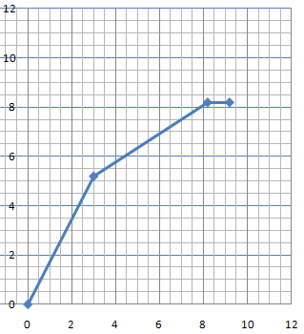
If we know the lengths of each of the arm segments and the angles that each segment makes with the last arm we can determine the final position of the end effector using some basic trigonometry. In the diagram the arms are both six units long, consider the third section as showing the direction the end effector points.
60
150
150

- Determine the final position of the end effector, using trigonometry, by determining the location of each of the joints in order.

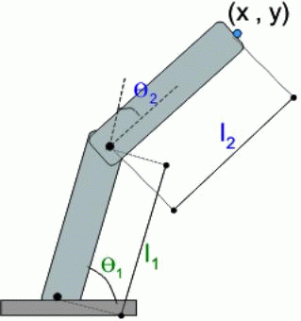
Inverse Kinematics
So if we know all the angles we can work out where the end effector will be. But often the more important question is: if we know where we want to be what do the angles need to be to get us there? The more degrees of freedom a robotic arm has the more difficult this problem becomes. Try holding an object in your hand in the same position while changing the angle of your shoulder, elbow and wrist. You’ll discover there are a number of different ways you can hold an object while achieving the same position. This is the same for robotic arms as well. Solving inverse kinematics for high degrees of freedom is incredibly difficult. But, for only two or three degrees of freedom we can again use some simple trigonometry.
Let’s say we have a car manufacturing plant with a robotic arm that does some welding. It needs to weld at two points (8, 3) and (8, 5), as shown below.
- What angles do the joints of the arm need to have to get to these positions?
The dashed lines have been added to help you solve this.
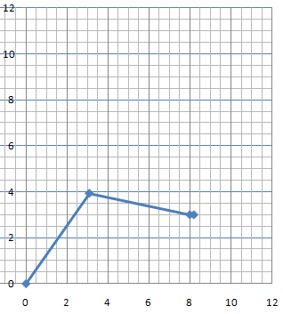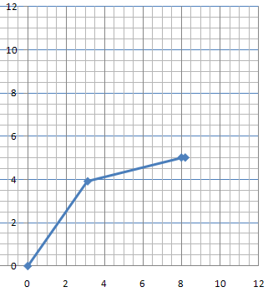
X = 8
X = 8
Y = 5
Y = 3
- What are the general equations that can be used to express the position of the end effector for any given values of (X, Y) and arm lengths L₁ and L₂?

